Drinks and mingle in the park
Sunday 2nd August
Kenwood Park, Hampstead Heath
Hampstead Lane, Hampstead, London NW3 7JR
Hosted by UK’s leading dating coach Jo Barnett

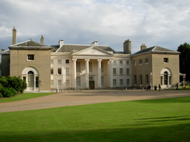

Ages 30 – 55

4pm Meet & Greet – mixers & games
4.30 Drinks and cake
5.00 mini speed dating meet ups
6.00 More socializing and a word from your hostess
7.00 All over!

